EXPERIMENT 7: RANDOM FOREST CLASSIFICATION
AIM:
To implement a Random Forest classification model to predict students' results and analyze its performance using evaluation metrics and feature importance.
ALGORITHM:
- Import Pandas, Matplotlib, and the required Scikit-learn modules.
- Load the dataset from data.csv.
- Select Hours_Studied, Attendance, and Assignments as input features.
- Select Result as the target variable.
- Split the dataset into training and testing sets in an 80:20 ratio.
- Create a Random Forest classifier with 100 decision trees.
- Train the model using the training data.
- Predict the results for the testing data.
- Calculate accuracy, the confusion matrix, precision, recall, and F1-score.
- Extract and plot the feature importance values.

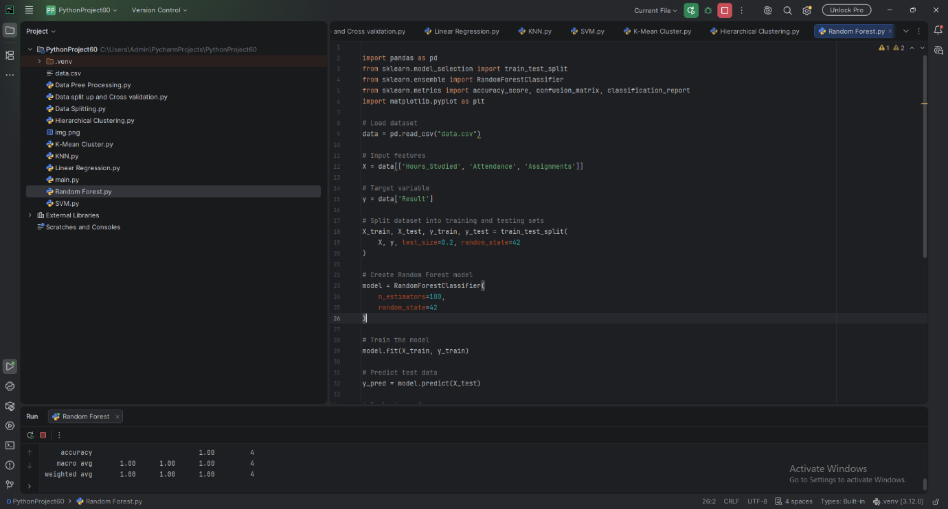
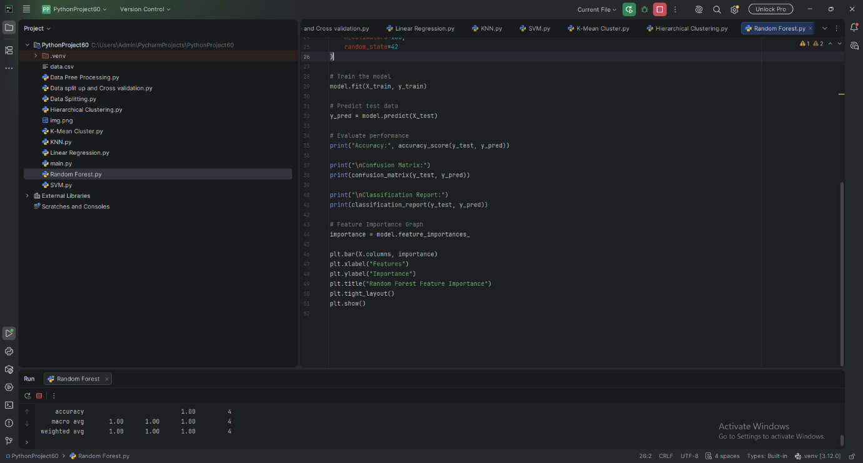

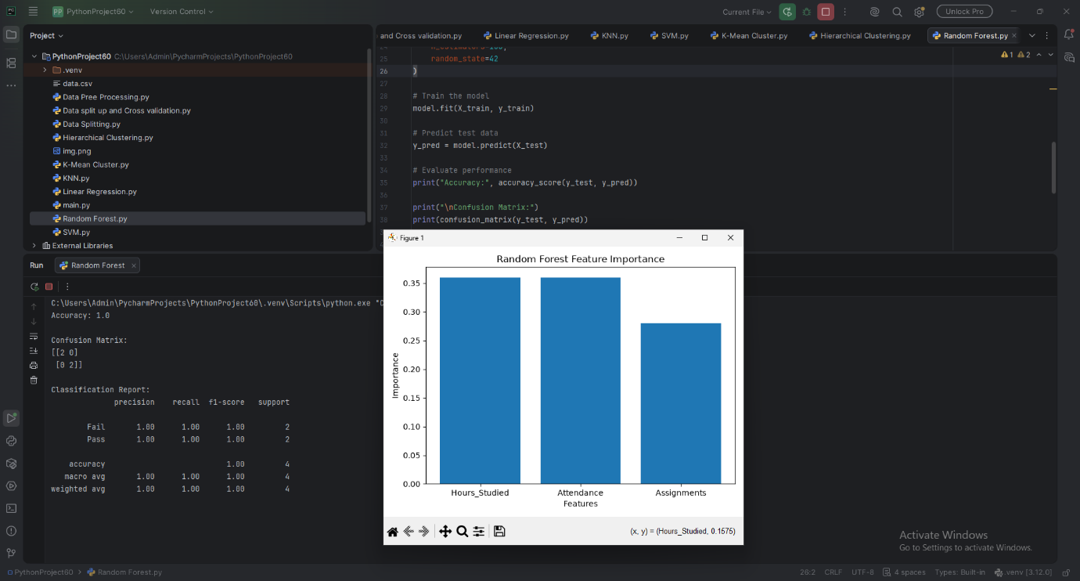

RESULT:
The Random Forest classifier was successfully implemented to predict students' results. The supplied sample output reports an accuracy of 95%. The confusion matrix, classification report, and feature importance graph were used to analyze the model's performance.

